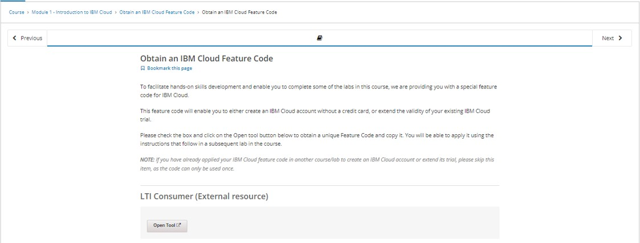

# Setting up Application Environment Create IBM Cloud Account

Team ID

Project Name

PNT2022TMID18116

Skill and Job Recommender Application

1. Visit to the ICT Academy SkillsNetwork Page by clicking on the link given below:

Link:

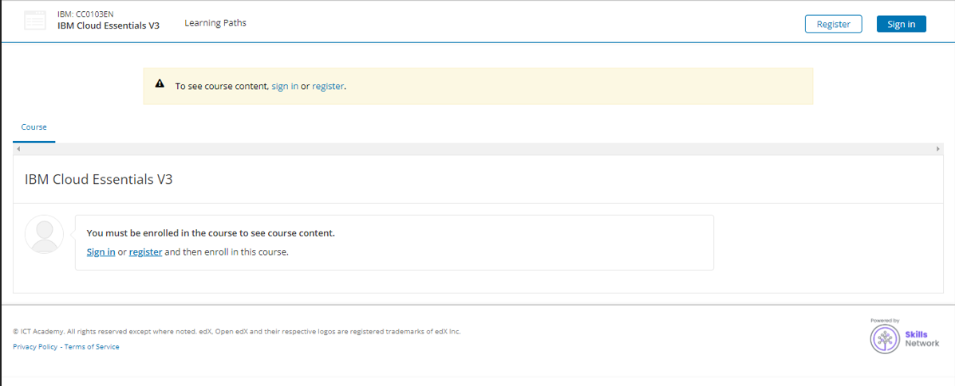https://courses.ictacademy.skillsnetwork.site/courses/course-v1:IBMDeveloperSk illsNetwork+CC0103EN+v3/course/

1. **Click on register**



1. **Fill in the below details for creating an account**

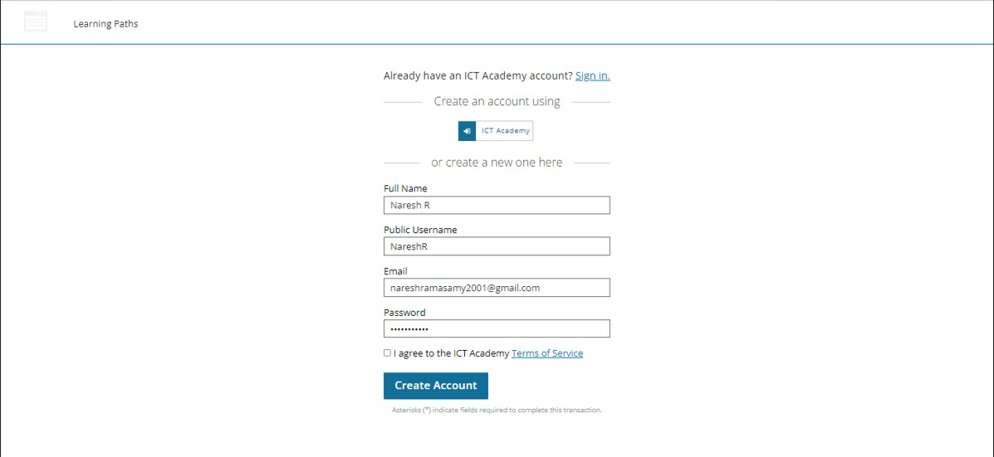



1. **Login to ICT Academy**

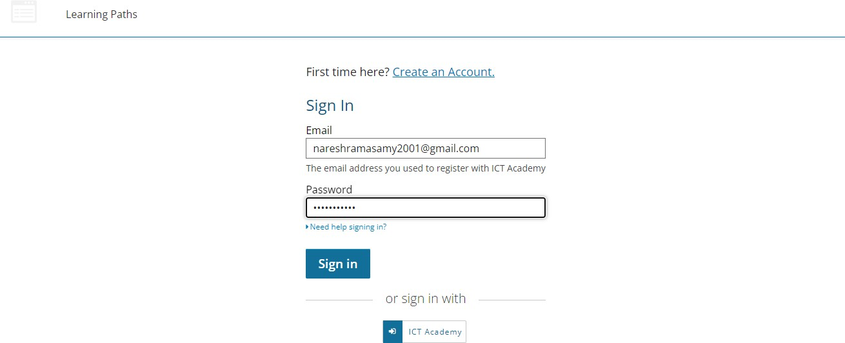

1. **Expand Module-1 and click on Obtain an IBM Cloud Feature Code.**

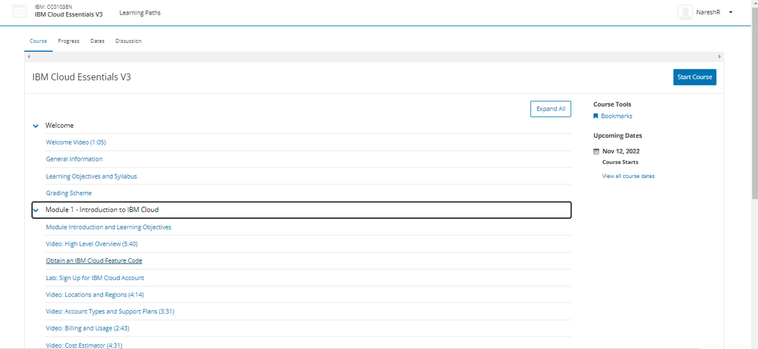

1. **Scroll down and click on the open tool to get the feature code for creating an IBM cloud account.**



1. **Click ok on the popup message to proceed to the next page.**

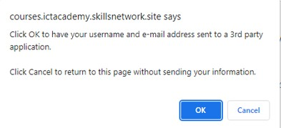

1. **Click on activate your trial account for 395 Days with the feature code**



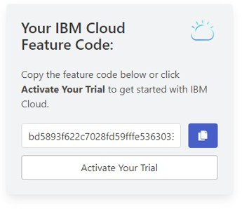



1. **Provide the same credentials i.e email id & password used for ICT**

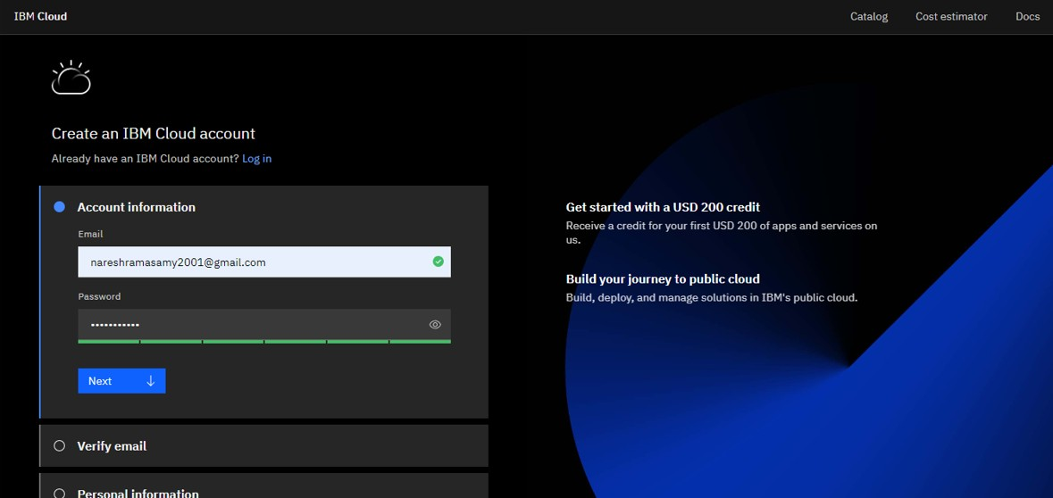Academy account creation and click on next to get the OTP on the registered email id.

1. **Provide the received OTP on the registered email id and click on next**

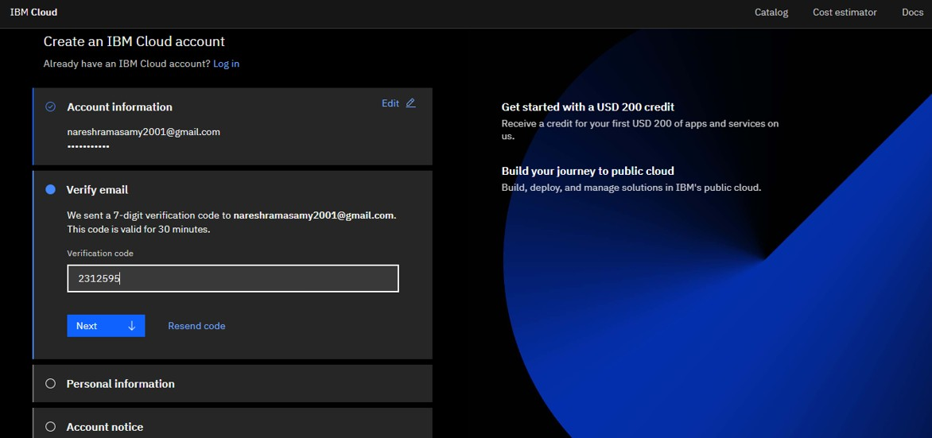



1. **Provide personal information and click on next**

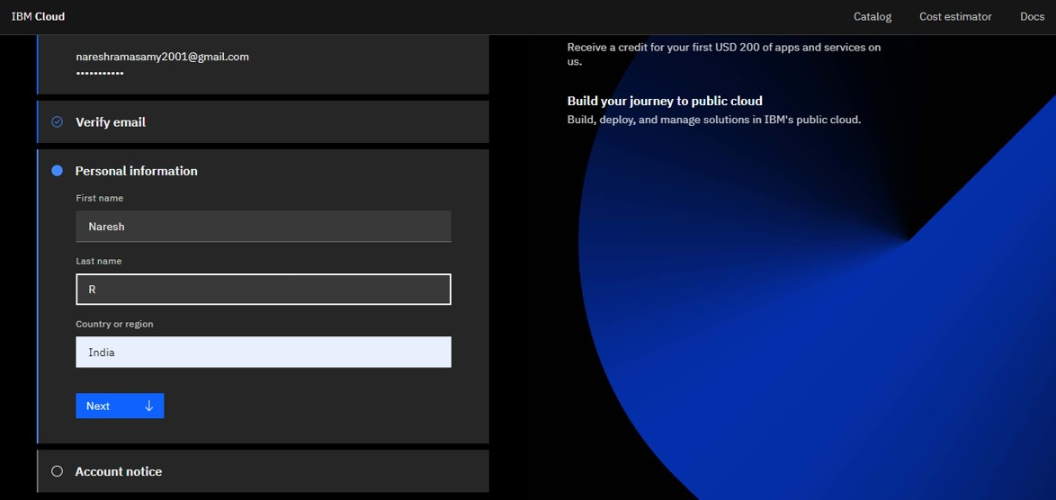

1. **Accept the terms and conditions then click on continue**

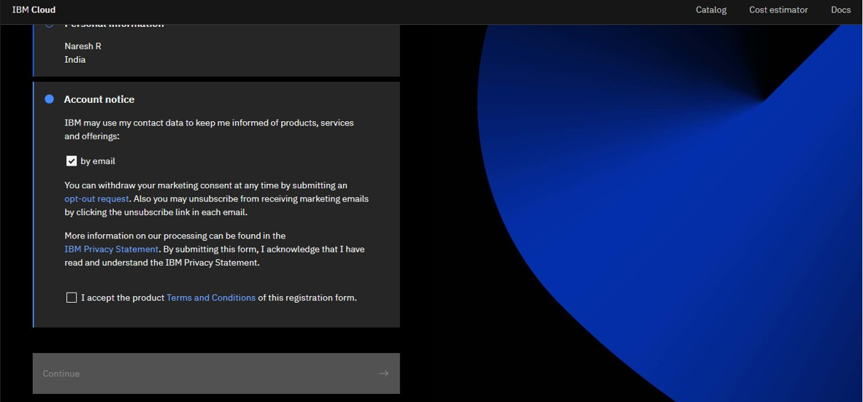



1. **Review account privacy notice mark the checkbox then click on continue**

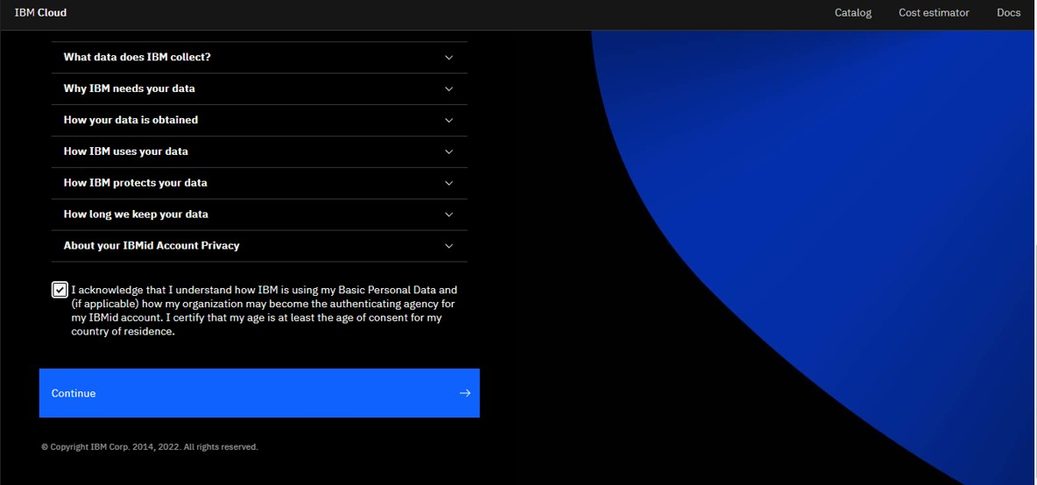

1. **Copy the feature code or continue with the filled feature code then click on create account**

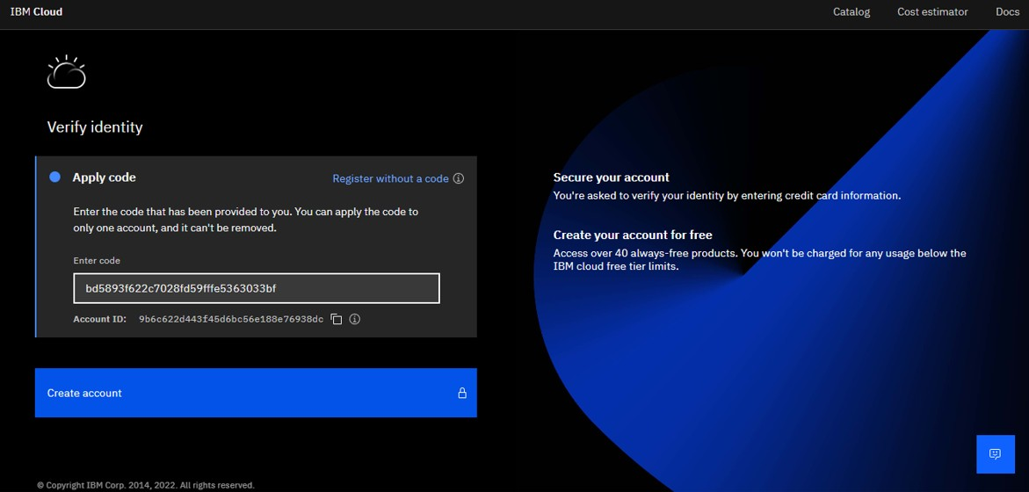



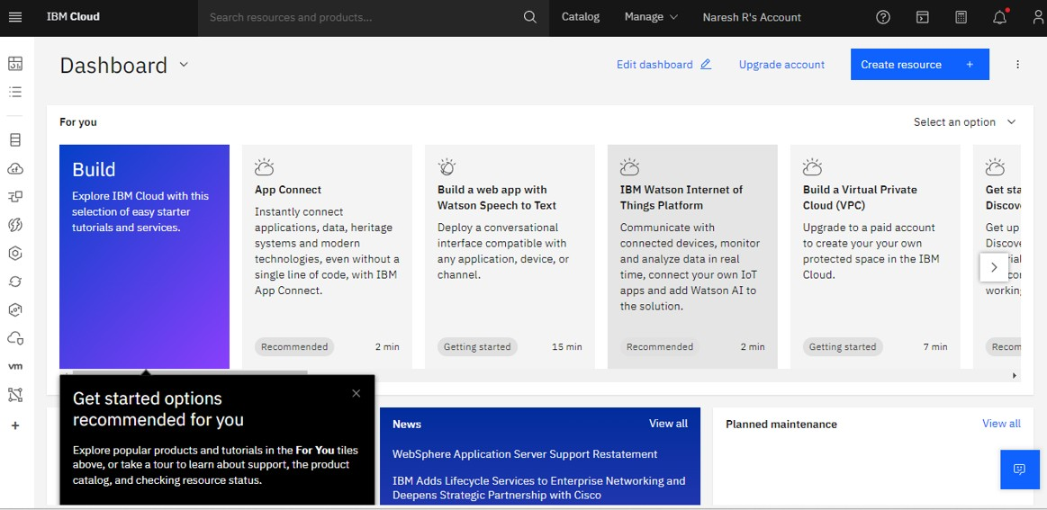

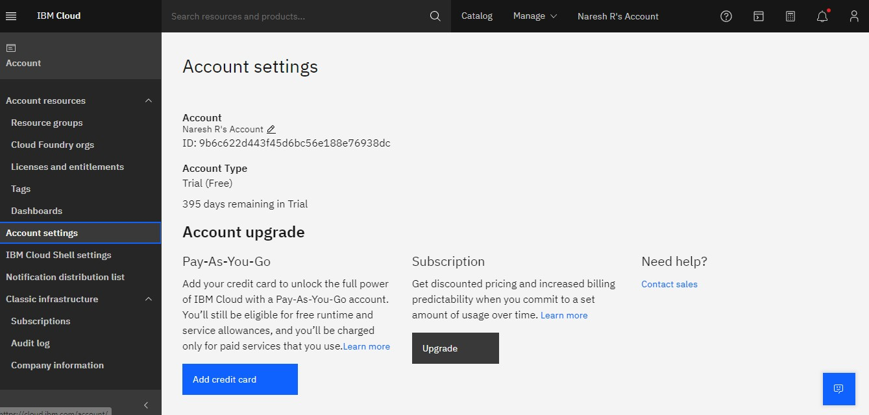

# Output :

Cloud account created successfully.